PROKARYOTIC CELLS
BY YOGESHWARI TIWARI
DEPARTMENT OF BIOTECHNOLOGY
GOVT.DIGVIJAY AUTO. P.G. COLLEGE RAJNANDGAON

INTRODUCTION
A cell is the basic unit of living things.
Living organism made of two types of cells - prokaryotic cells (unicellular)
- Eukaryotic cells(multicellular)

Prokaryotic (Greek word) – Pro = old or before
-Karyon = Nucleus

This type of cell doesn’t have a nucleus.
The most primitive type of cell

Definition - prokaryotes are organisms that do not have a nucleus
They lack a membrane-bound nucleus; they include bacteria and cyanobacteria, and single-cell organisms.
History - the concept of the cell originated from the contributions of Schleiden and Schwann in 1838. However, it was only after 1940 that the complexity of the cell structure was exposed.
structure of prokaryotic cells
part of a prokaryotic cell –
Capsule - prokaryotes have a sticky outermost layer called a capsule, which is usually made of a polysaccharide.
cell wall - all prokaryotic cells have a stiff cell wall located under the capsule. This structure maintains the cell shape.
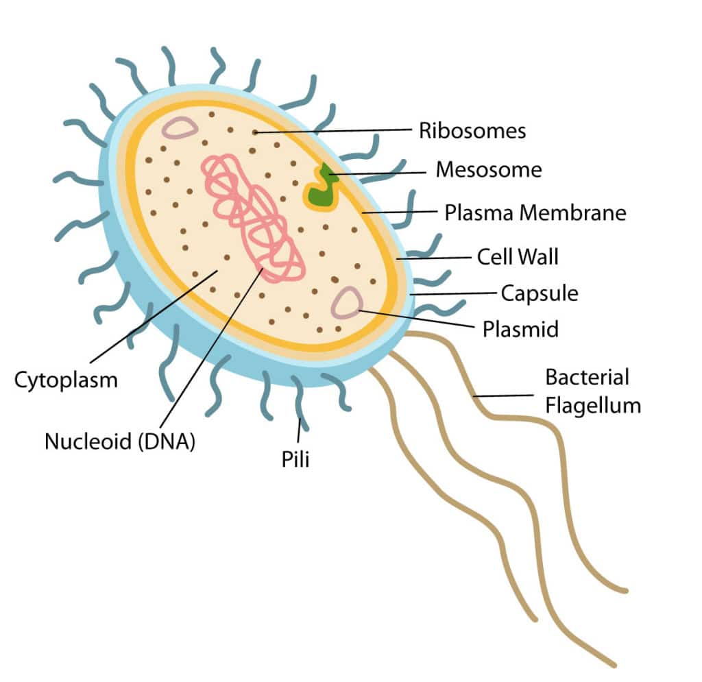
plasma membrane - both prokaryotic and eukaryotic cells have a plasma membrane.

Flagella – Flagella are primarily used for sexual reproduction and are found in prokaryotes as well as some eukaryotes.

Pilli - Pilli are short, hair-like structures on the cell surface of a prokaryotic cell
Nucleoid – area around the genetic material of prokaryotic cells.

Fimbriae - hair-like protein structures, allow prokaryotes to stick to the surface in their environment and to each other

Ribosome - all prokaryotes have 70 S ribosome a 70S ribosome is made up of a 50S and 30S subunit.

Mesosome - they help in the synthesis of the cell wall and the application of the DNA; they also help in an equal distribution of chromosomes into the daughter cell.

Cytoplasm - the site of class in a prokaryotic cell, is a gel-like structure in which all of the other seller components are suspended.
Features of prokaryotes
- : no nucleus – an instant nucleus is the nucleoid, divided at the nuclear membrane.
- There are no organelles with a membranous structure.
- have a mesosome that functions as a membrane-organized organised.

