NUCLEUS

BY YOGESHWARI TIWARI
DEPARTMENT OF BIOTECHNOLOGY
GOVT.DIGVIJAY AUTO. P.G. COLLEGE RAJNANDGAON

INTRODUCTION
The nucleus was discovered by the English biologist Robert brown in 1831.
It is an important part of a cell, exerting a controlling influence on all cell activities.
it is usually a spherical or oval structure, mostly located in the centre of the cell.
Some sieve tubes of vascular plants and the red blood cells of mammals lack nuclei.
the nucleus is a membrane-bound structure that contains the cell's hereditary information and controls the cell's growth and reproduction.
Occurrence - found in all eukaryotic cells of plants and animals.
exception - mature erythrocytes and prokaryotic bacteria lack a nucleus.
Structure of the nucleus-
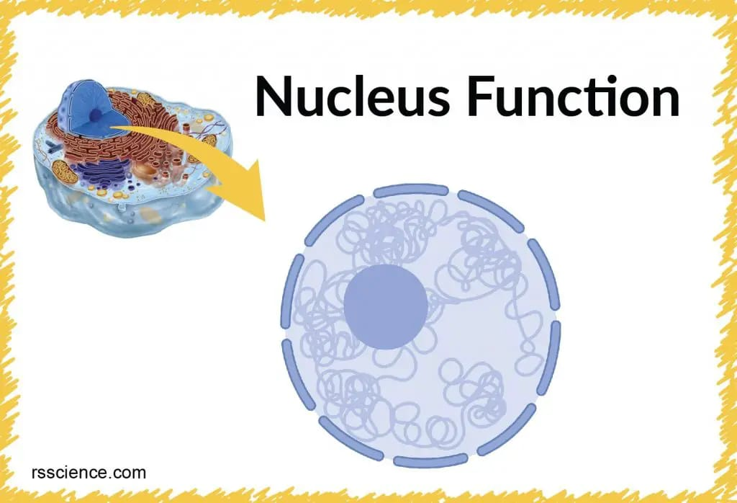
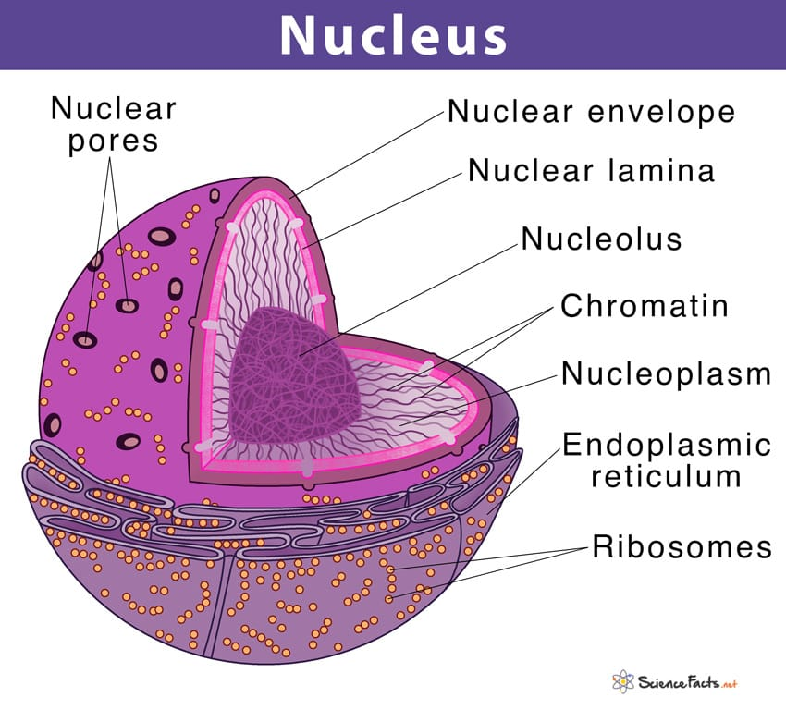

The average diameter of the nucleus is 6 μm, which occupies around 10% of the cell volume nuclear envelope is the double-layer membrane enclosing the nucleus of a eukaryotic cell.
The nuclear envelope has a force that allows the passage of materials into and out of the nucleus.
Prokaryotes are organisms that do not have a nucleus.
They lack a membrane-bound nucleus; they include bacteria and cyanobacteria, and single-cell organisms.
Nuclear membrane - a nuclear membrane, also known as nucleolemma.
it is the phospholipid bilayer membrane that surrounds the genetic material and nucleus in eukaryotic cells.
The nuclear membrane consists of two lipid bilayers: the inner nuclear membrane and the outer nuclear membrane nucleoid
Nucleolus - in the nucleus, takes up around 25% of the volume of the total nucleus.
This structure is made up of proteins and ribonucleic acid. Its main function is to rewrite ribosomal RNA and combine it with proteins. This results in the formation of incomplete ribosomes.
chromosome -chromosomes are the thread-like structures found in the nucleus of both animal and plant cells. They are made up of protein and one molecule of deoxyribonucleic acid.
Nucleoplasm - just like the cytoplasm found inside the nucleus contains nucleoplasm, also known as karyoplasm.
This nucleoplasm is a type of protoplasm that is made up of mostly water mixture of various molecules, and dissolved ions.

Function of the nucleus
control cellular function
important role in cell division
control the synthesis of all structural and enzymatic proteins.
genetic variation
helps in organic evolution

