CHLOROPLAST

BY YOGESHWARI TIWARI
DEPARTMENT OF BIOTECHNOLOGY
GOVT.DIGVIJAY AUTO. P.G. COLLEGE RAJNANDGAON

Introduction:
Chloroplasts are located predominantly in mesophyll cells of leaves. Chloroplasts are plant organelles where the Solar or Radiant energy is converted into chemical energy in the form of organic food material.
Discovery
of chloroplasts was described as early as the 17th century by Nehemiah Grew and Anton von Leeuwenhoek.
The term plastid was used by Schimper in 1885. He also classified the plastic of plants.
Occurrence –
found in all photosynthetic cells in plants is also found in some protists like Euglena.
completely absent in fungi, bacteria, and animals.
Algae usually have a single chloroplast, whereas cells of higher plants have 22- 40 chloroplasts.
Size –
It varies from plant to plant. It is generally one to three micrometers in thickness and five to 10 micrometers in diameter.
Numbers –
The number of chloroplasts in the cells of a plant is almost similar.
Higher plants generally have 20 to 40 chloroplasts in their cells. In Clamidomonas, a single chloroplast is found
Ultrastructure of chloroplast –
It is formed of the following parts
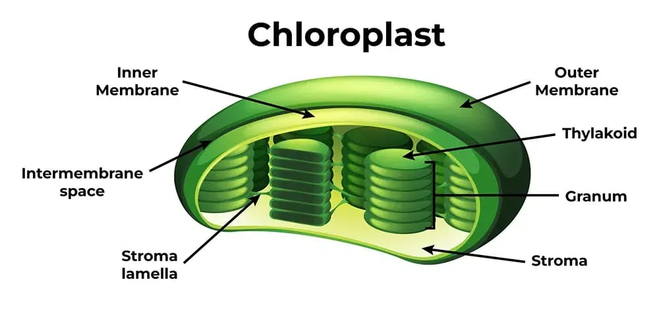
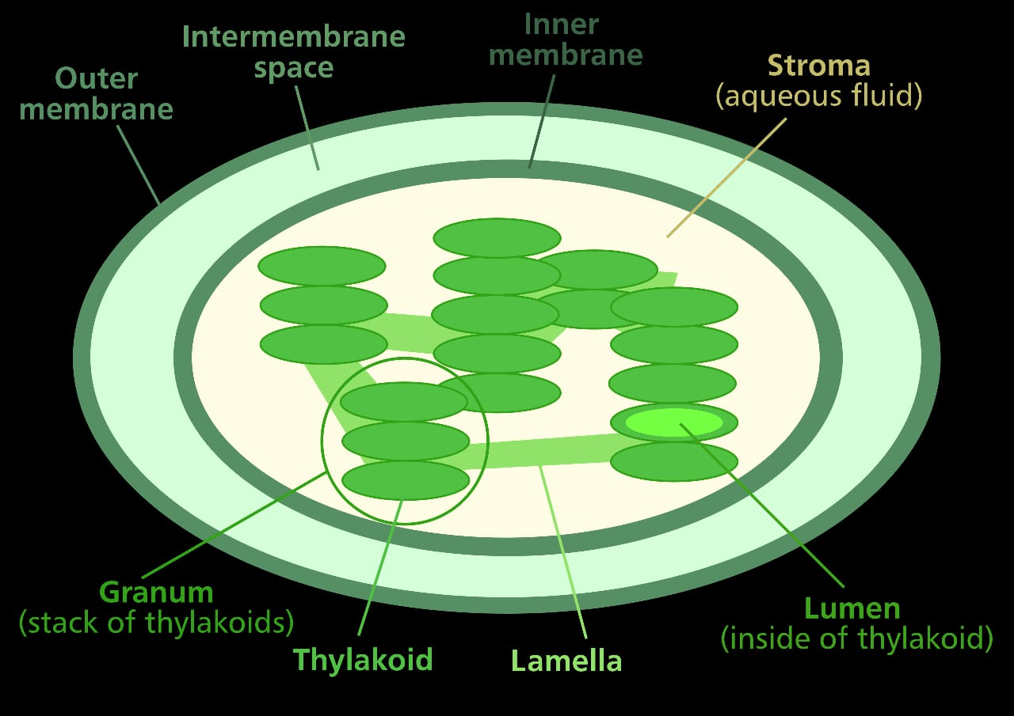

Envelope- each of the chloroplasts is surrounded by a double layer of lipoprotein membrane.
The outer layer has less protein and more permeability.
The inner layer has more semipermeable protein.
The membranes are apart from each other by a distance of 22 - 75 angstroms across this double membrane envelope, and exchange the molecules between the chloroplast and cytosol occurs.
Stroma - a dancer granular and colourless ground substance present inside the inner plastid membrane is called stroma, circular and net, also known as matrix.
It contains protein 70s ribosome and DNA
Grana in higher plants are many oval-shaped closed sacs found within the stroma of the chloroplast, which are known as thylakoids.
thylakoids are stacked over each other and form a small cylindrical structure called grana.
A chloroplast is a semi-autonomous organelle that contains its own DNA.

