Plantation

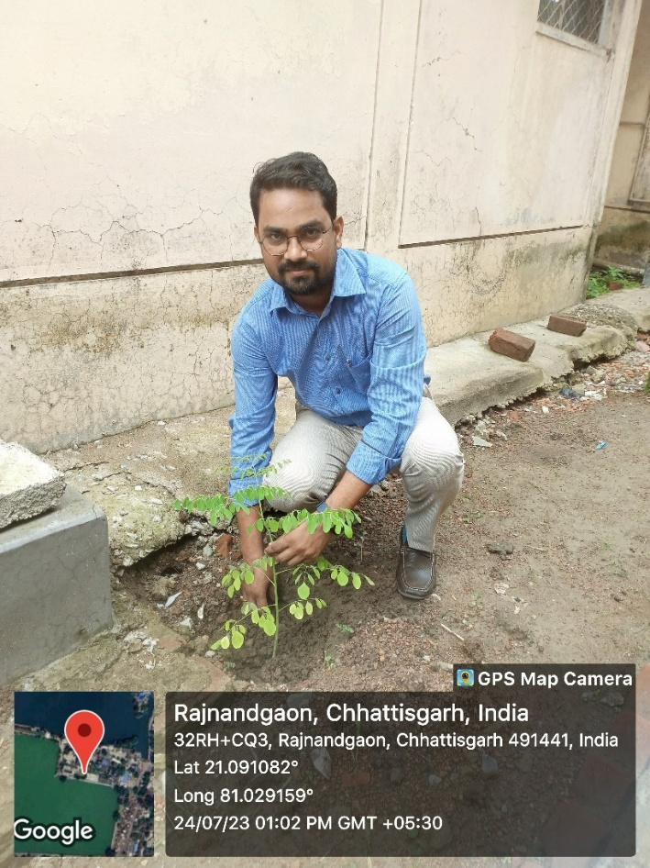

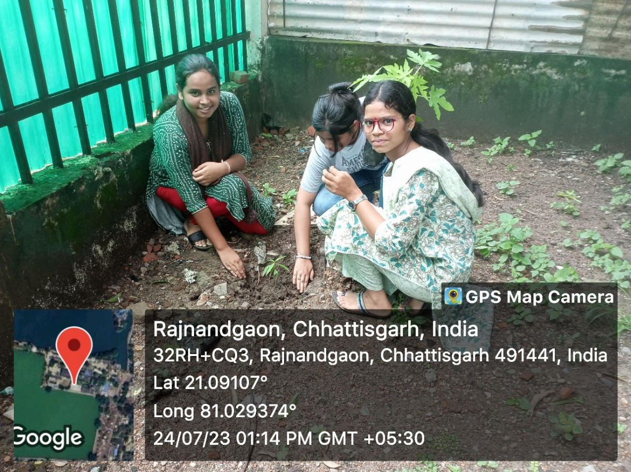

Celebration of Important Days
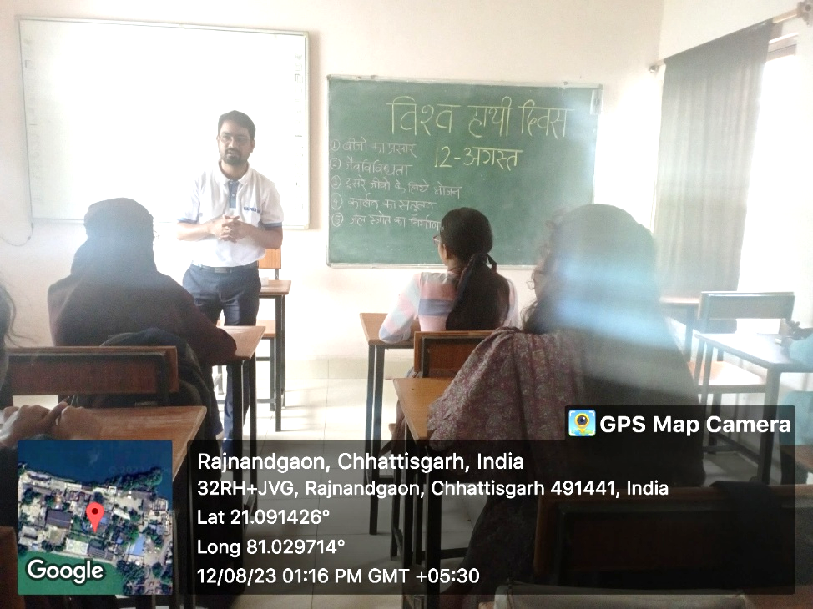

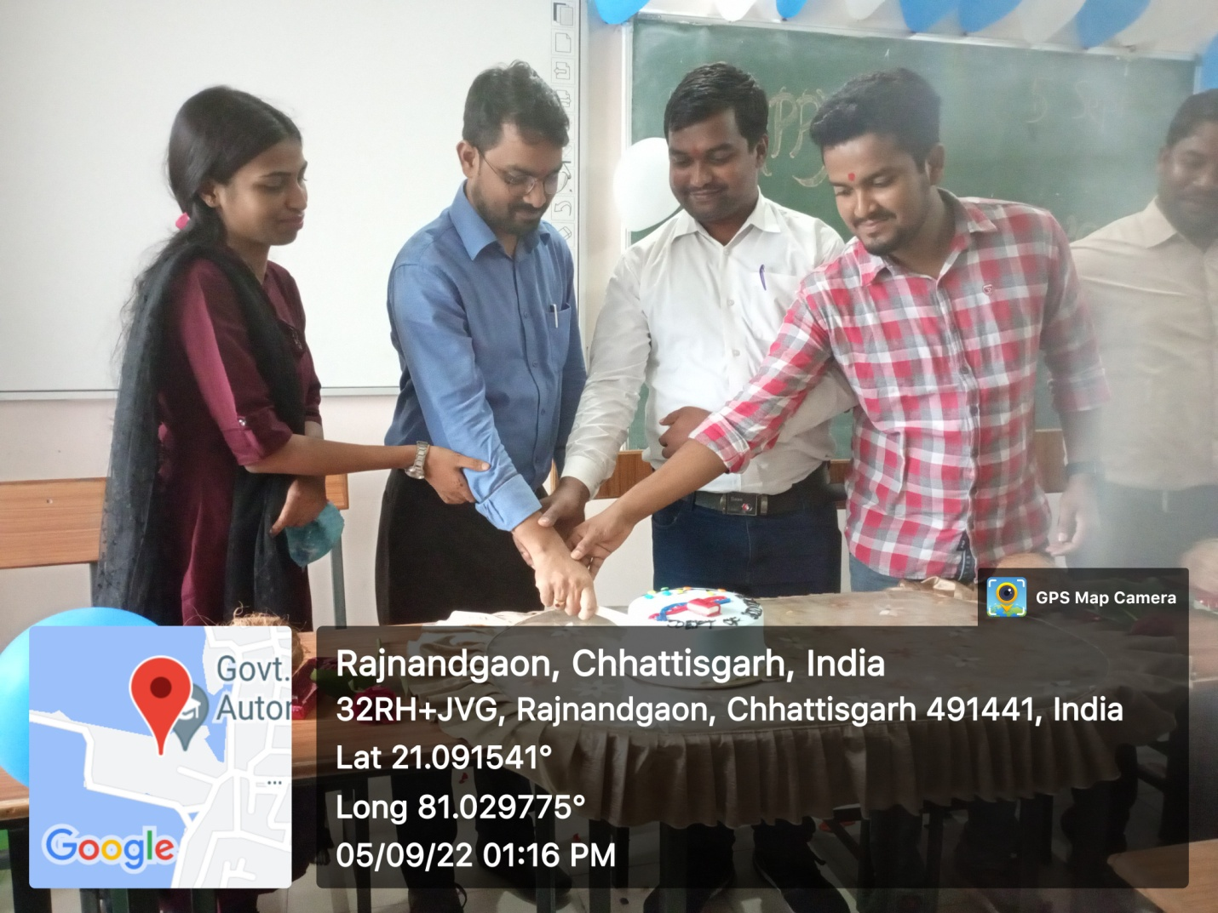
Celebration of Teacher’s Day Celebration in

APJ Abdul Kalam Birthday Celebration
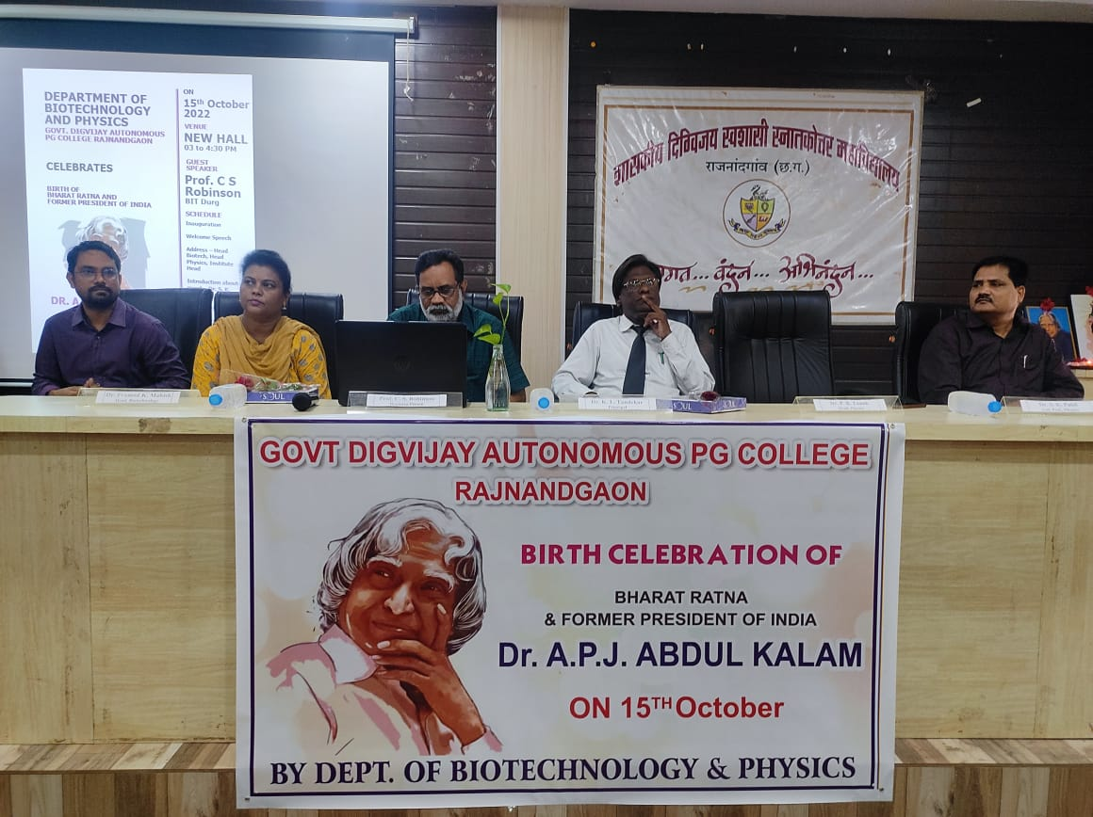

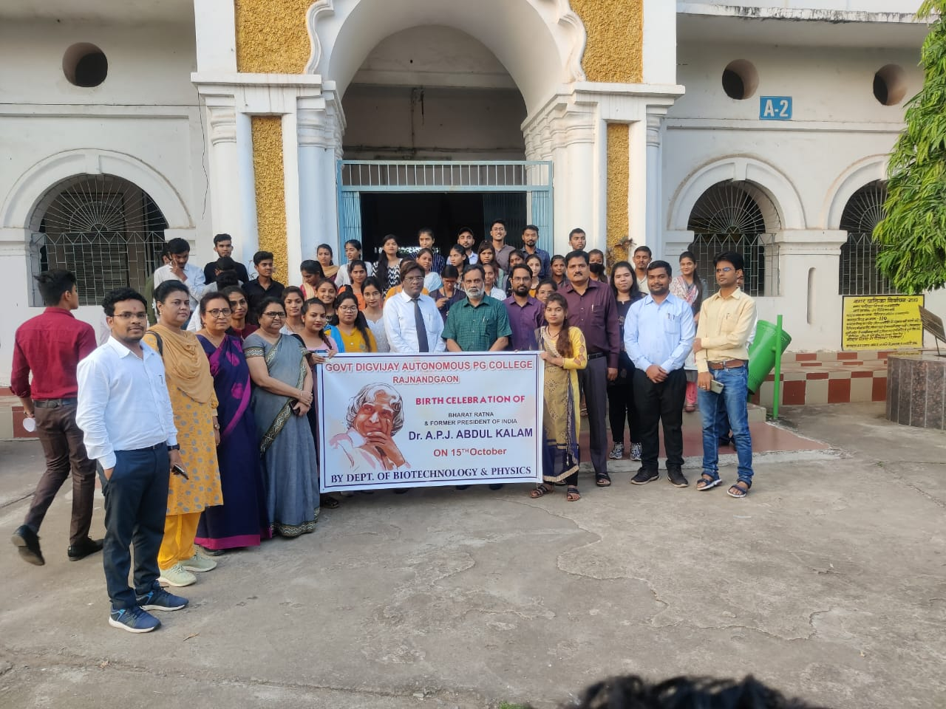

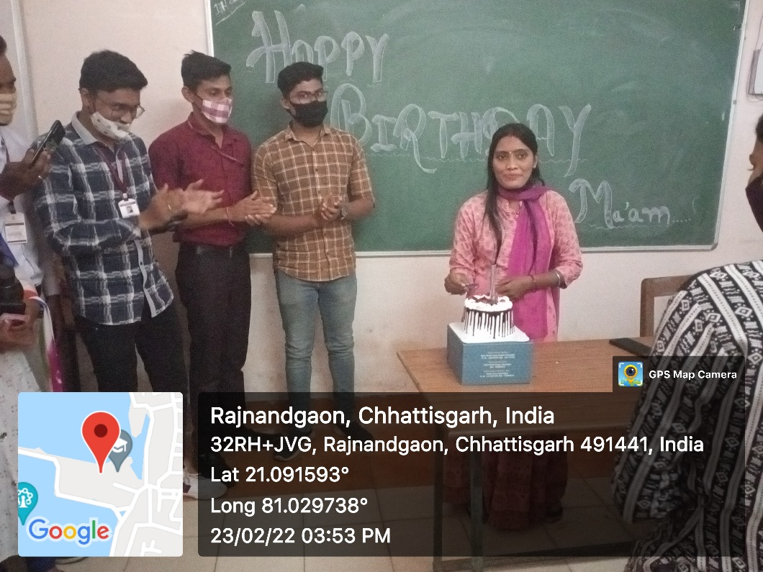

Activity related to health deeds
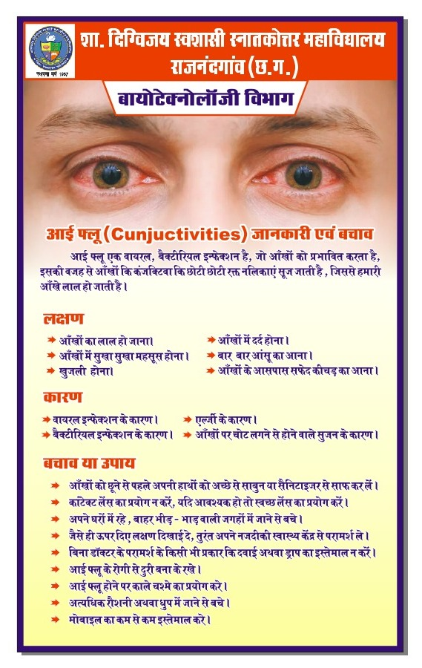

Invited Lecture in the Department

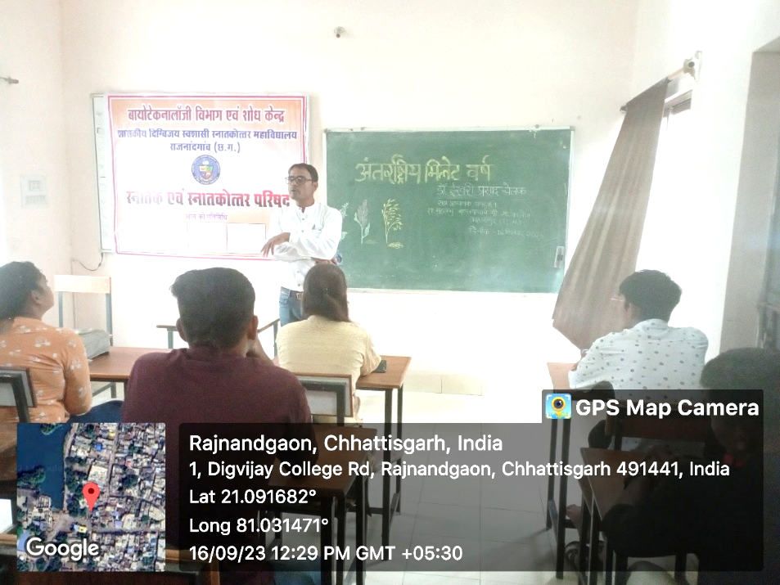
Dr. Ishwari Prasad Chelak From Mahasamund PG College

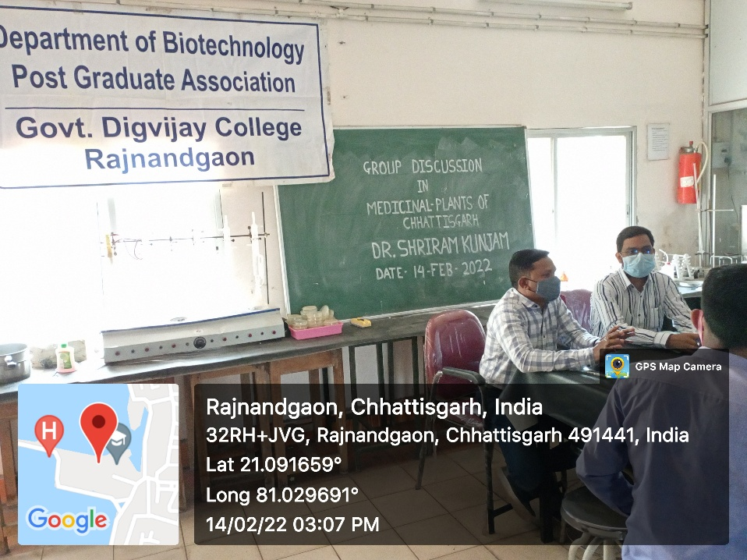
Dr. Shriram Kunjam From Govt. VYT PG College Durg

Activities under MOUs
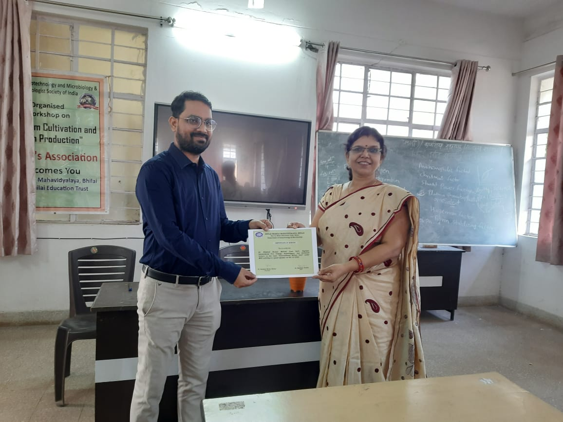
Lecture delivered in Bhilai Mahila Mahavidylaya College Under MoU

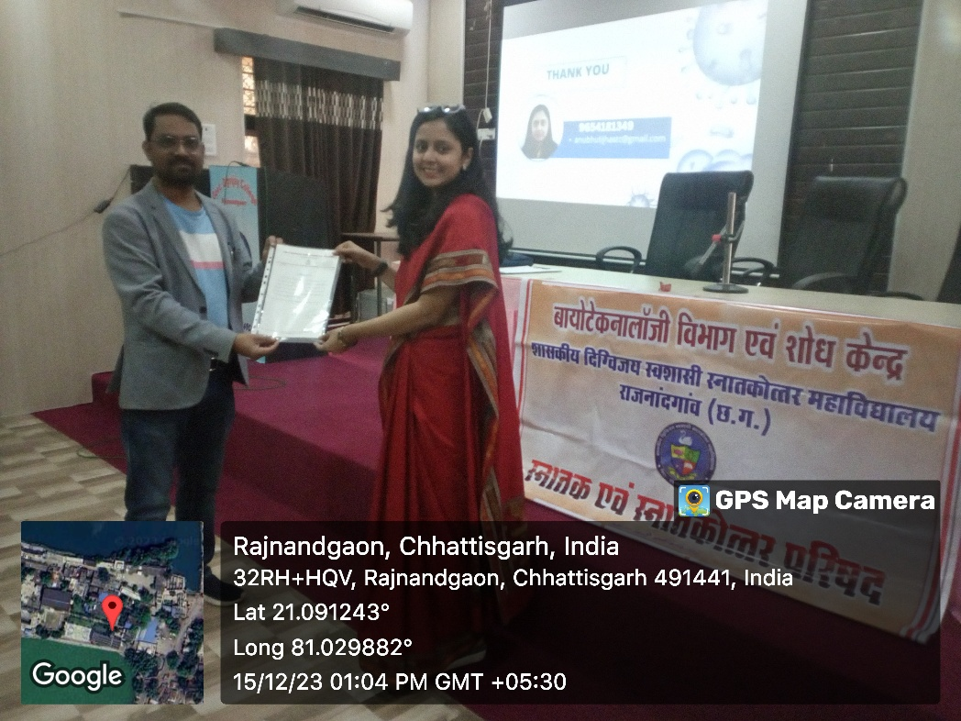
Lecture delivered in the department by Dr. Anubhuti Jha, St. Thomas College under MoU

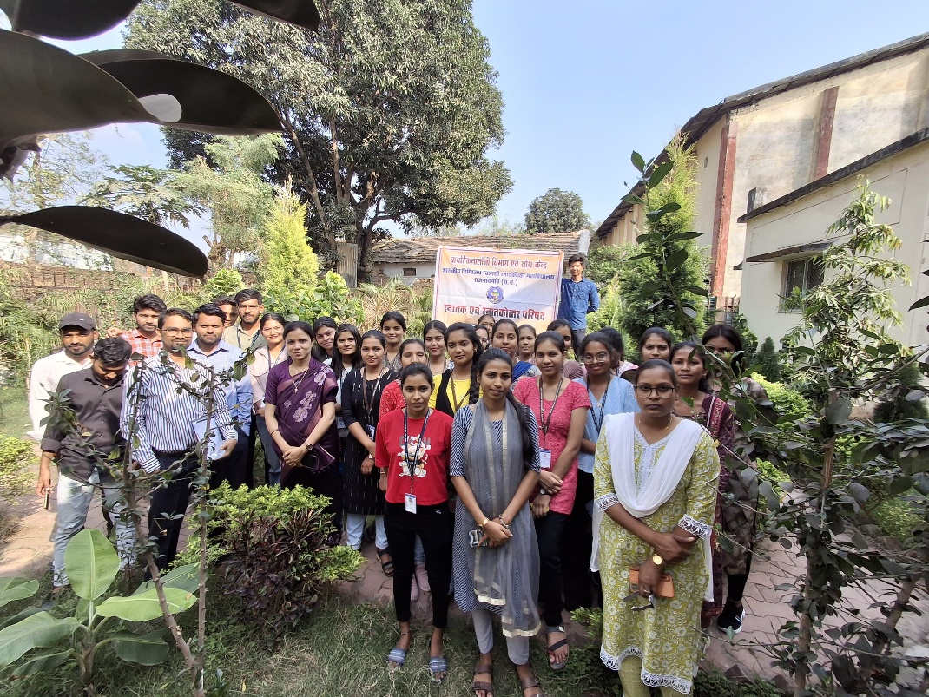
Field activity exercised by Dr. Shubha Diwan St. Thomas College Bhilai under MoU

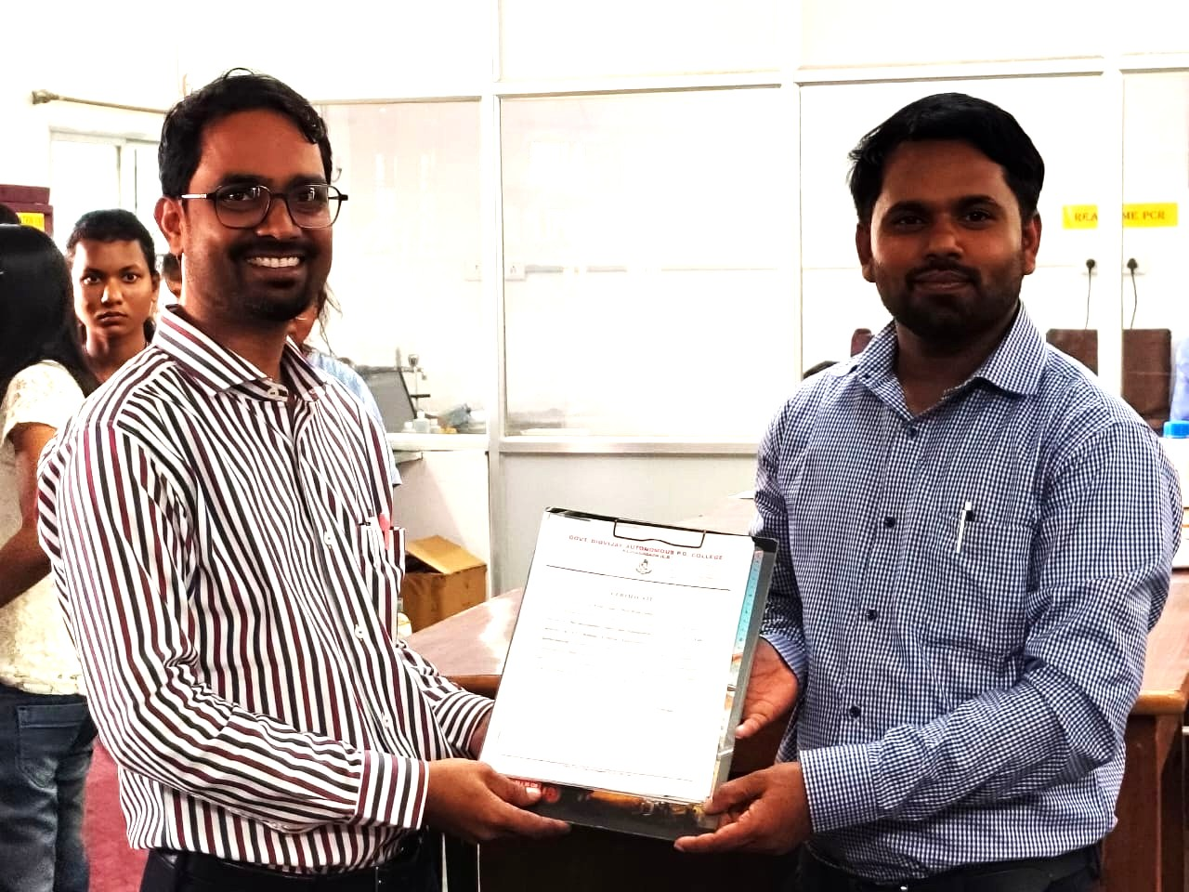
Instrumentation workshop by Dr. Motiram Sahu, Govt. VYT PG College Durg under MoU

Skill Development activity
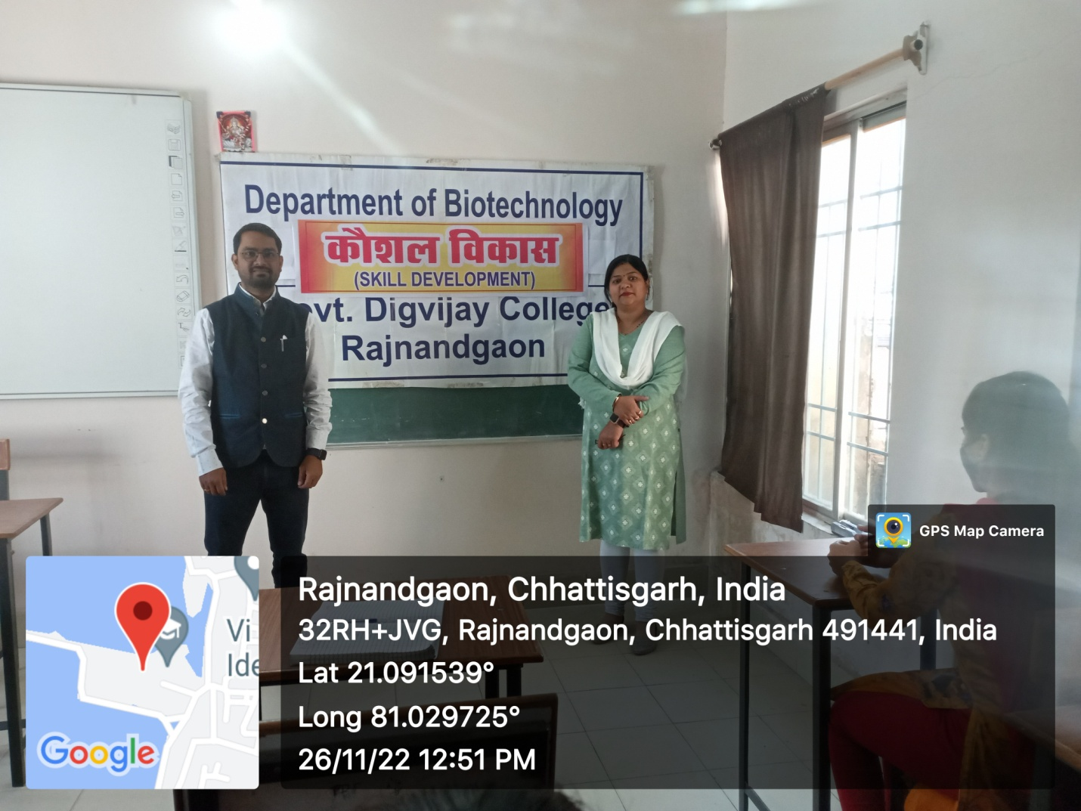
Invited Lecture delivered by Dr. Soumya Khare, HOD Biotechnology on global Food Safety

Career Guidance activity
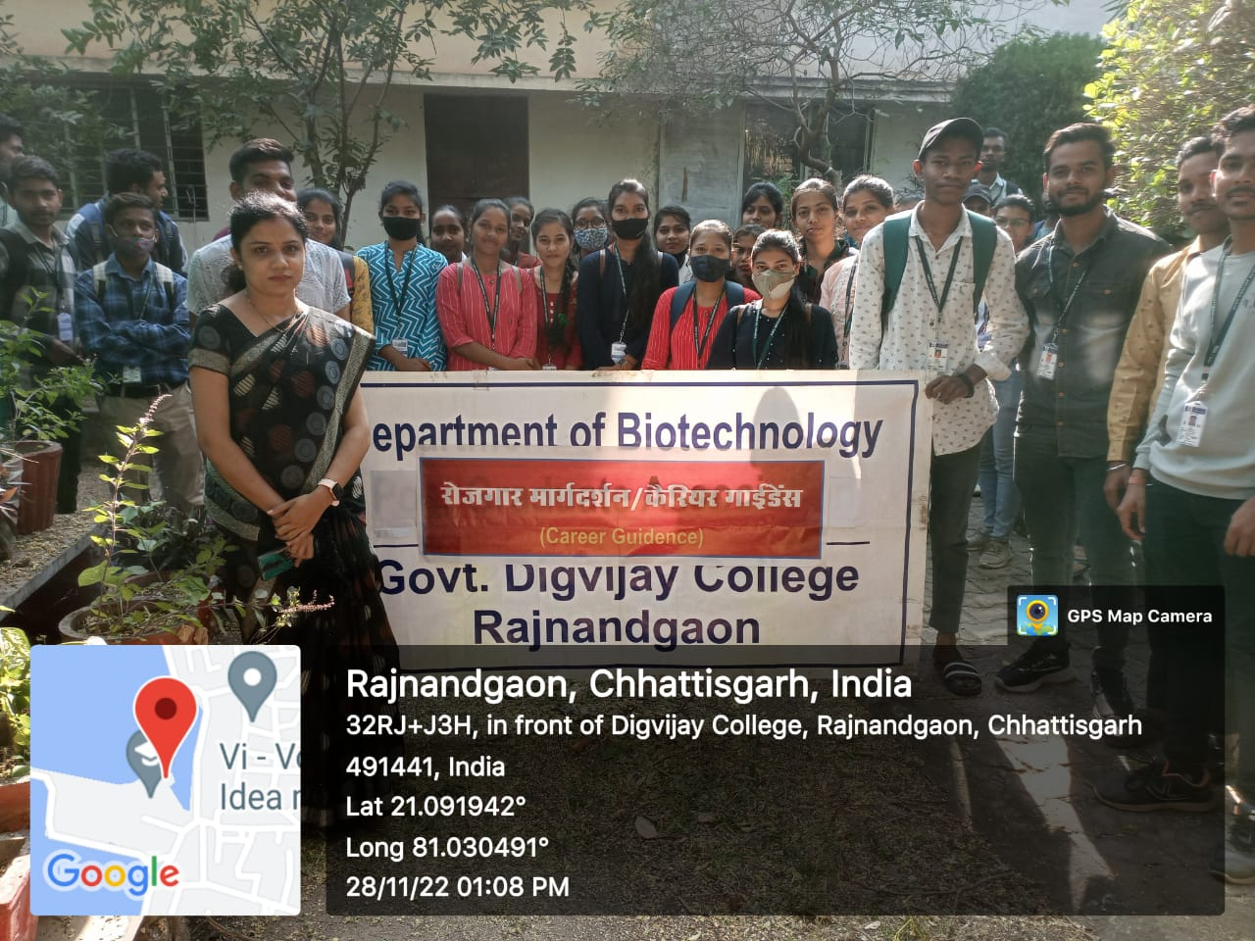
Career Guidance provided by Dr. Shubha Diwan, Asst. Professor of Biotechnology to B.Sc. III yr Students on “Plant Tissue Culture”

Academic/ Industrial Visit
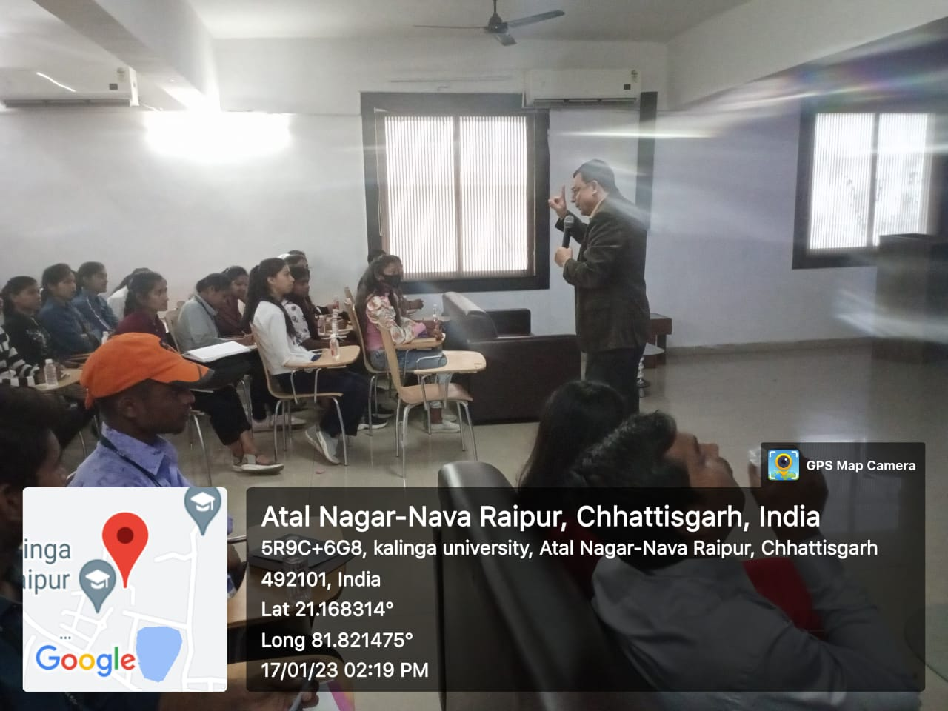
Academic visit and interaction with Vice Chancellor of Kalinga University Raipur

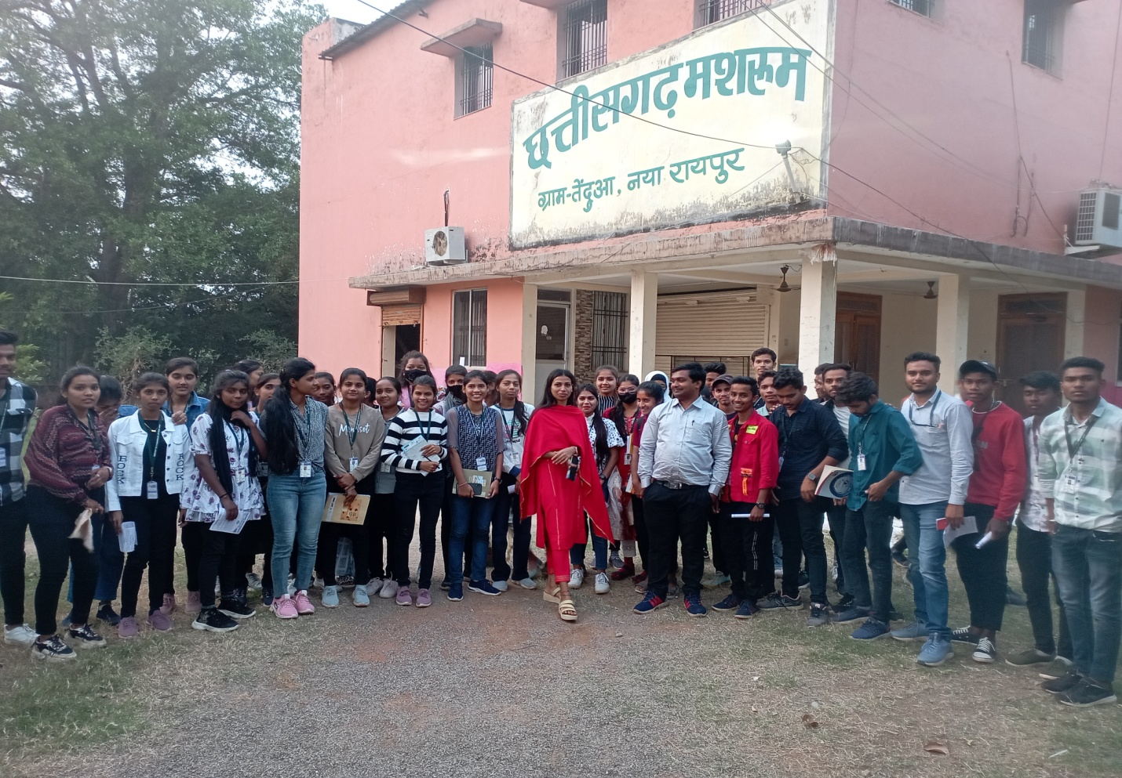
Chhattisgarh Mushroom Production center.
Date: 17/01/2023; No. of beneficiaries 49 students of UG

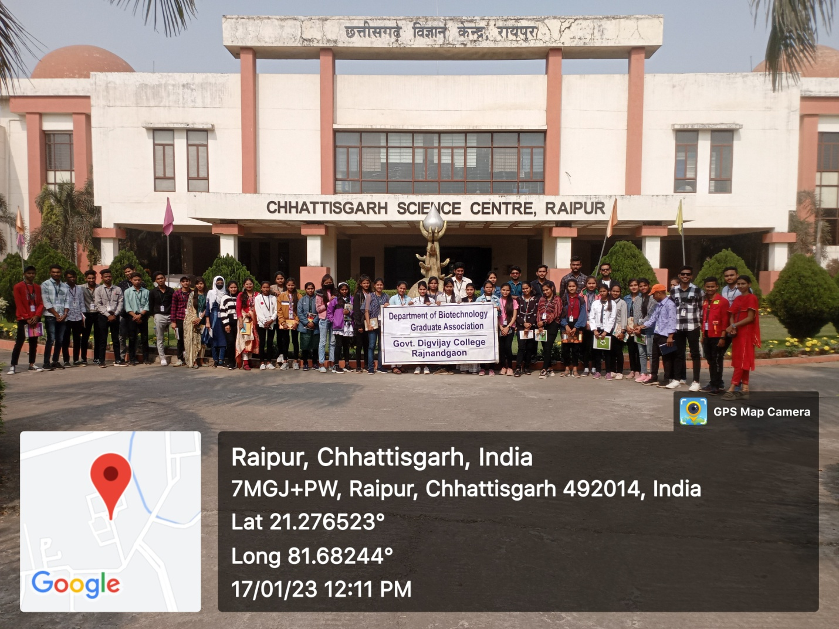
Educational visit in science centre Raipur

Outdoor Class
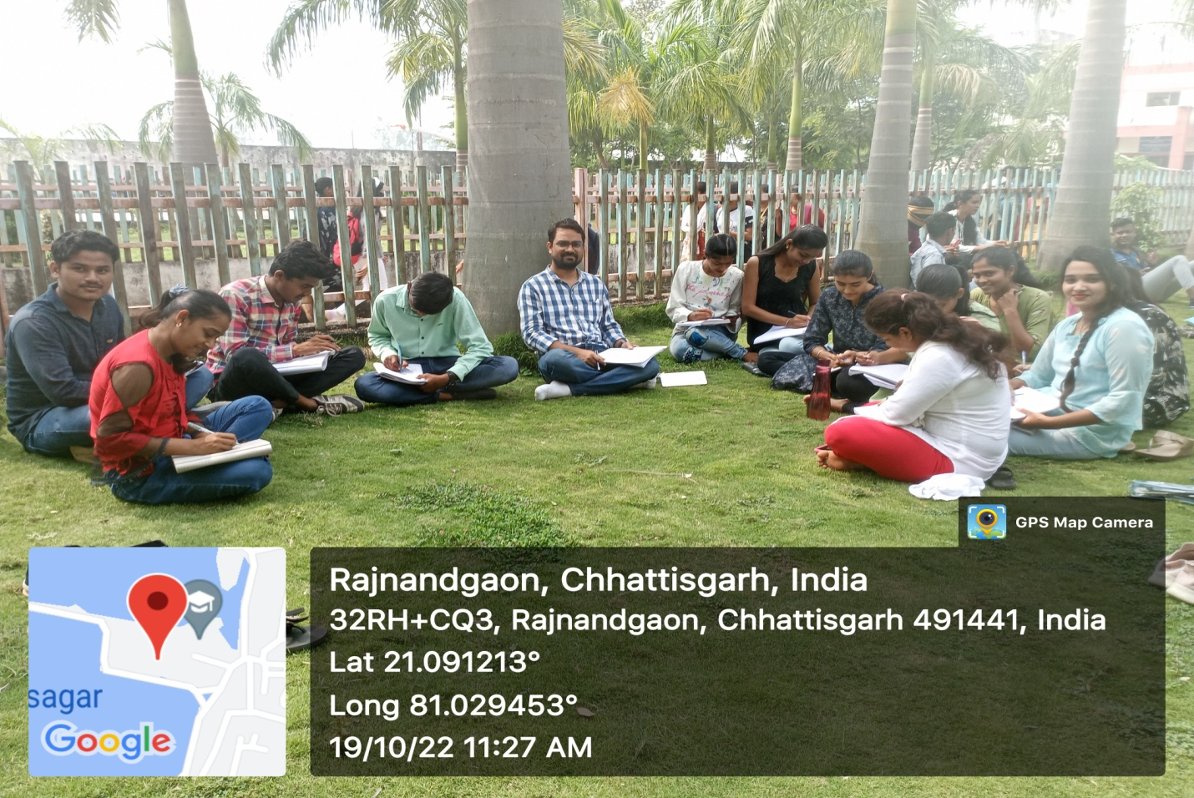

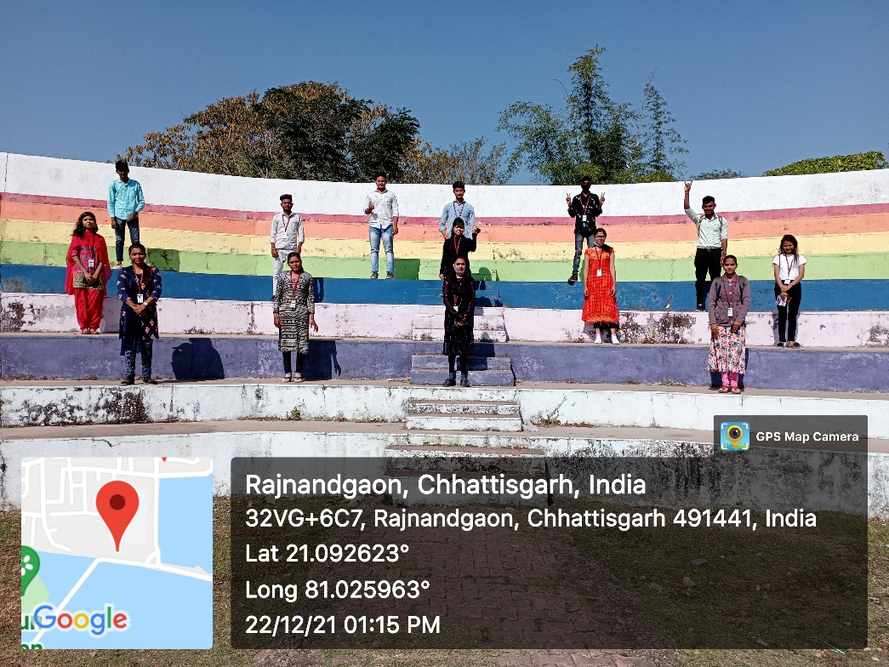

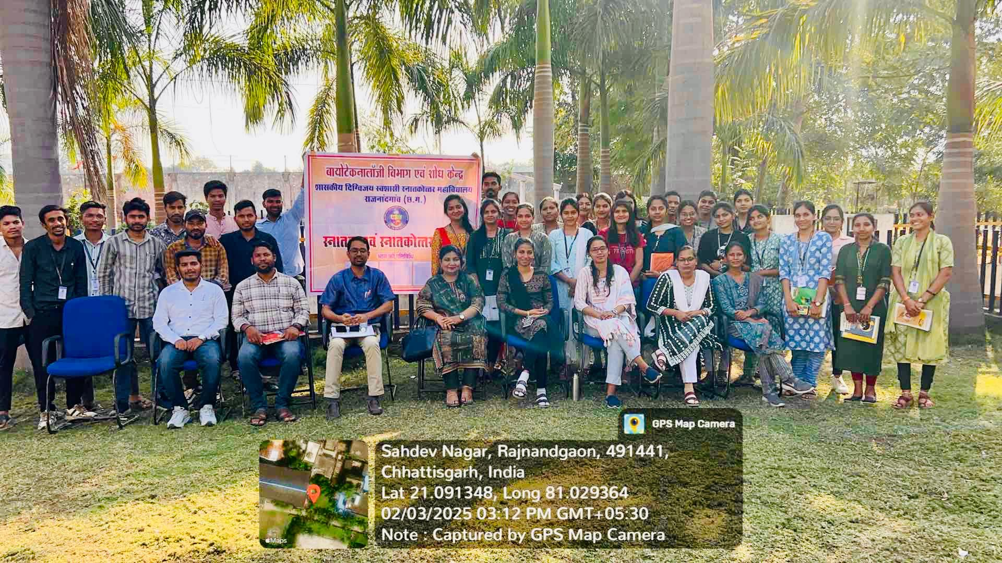

Participation in Conferences
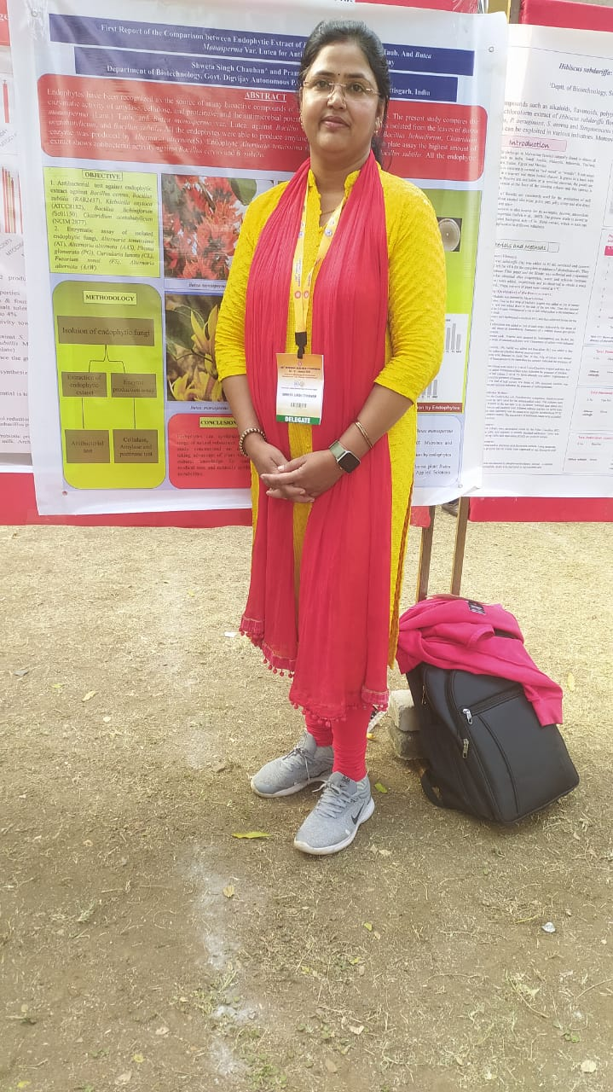

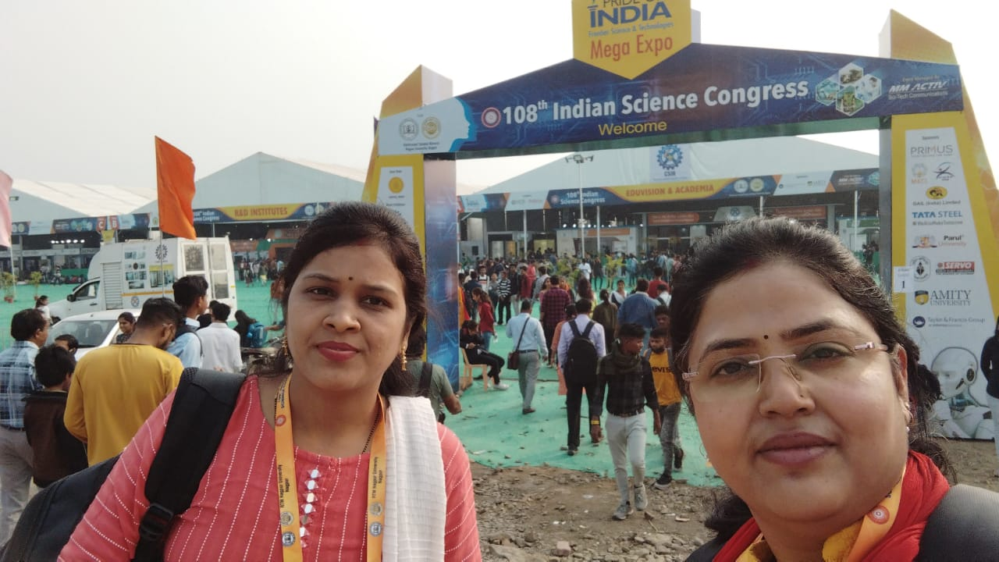

Participation in 108th Indian Science Congress at Nagpur by Research Scholars

Major Experiments Performed in the Department
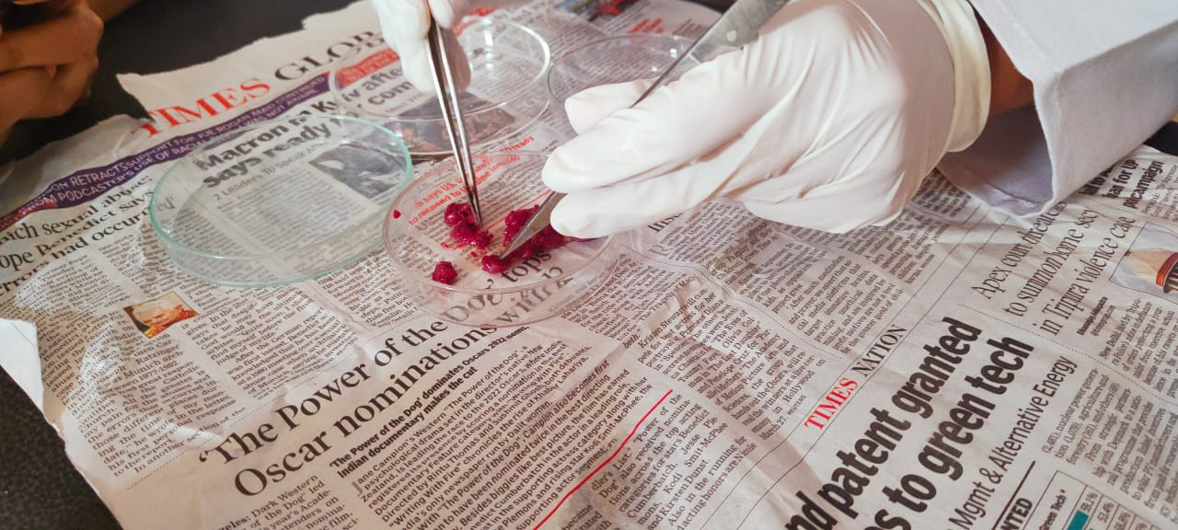

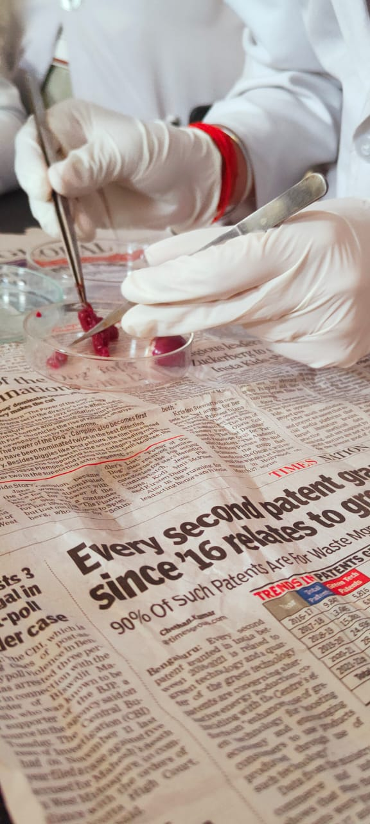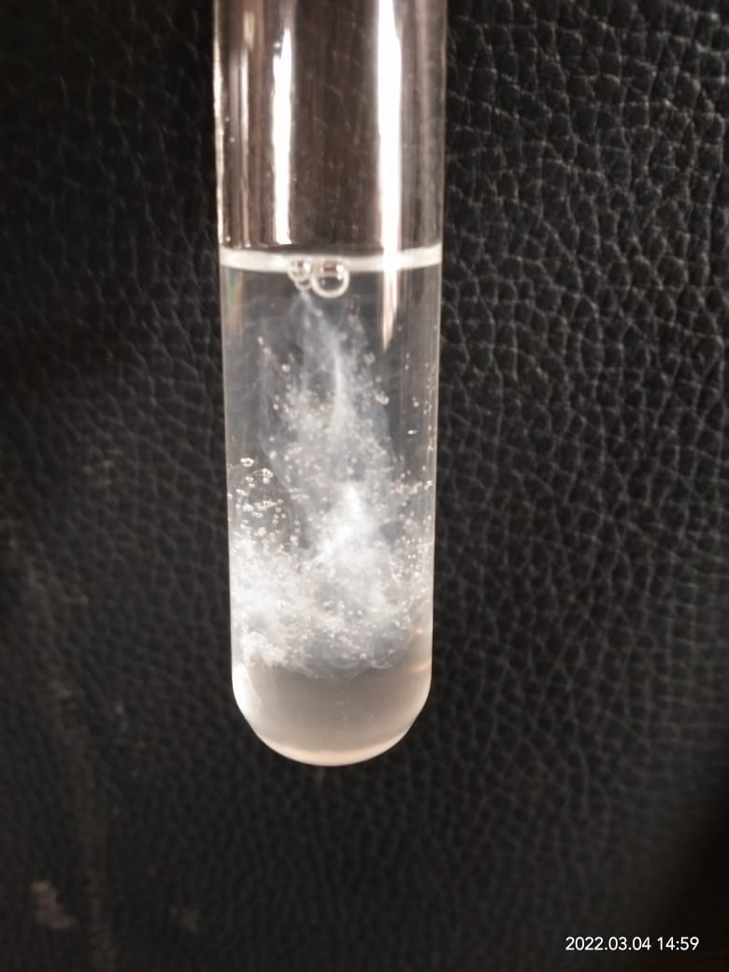

DNA Isolation from Plant and Animal

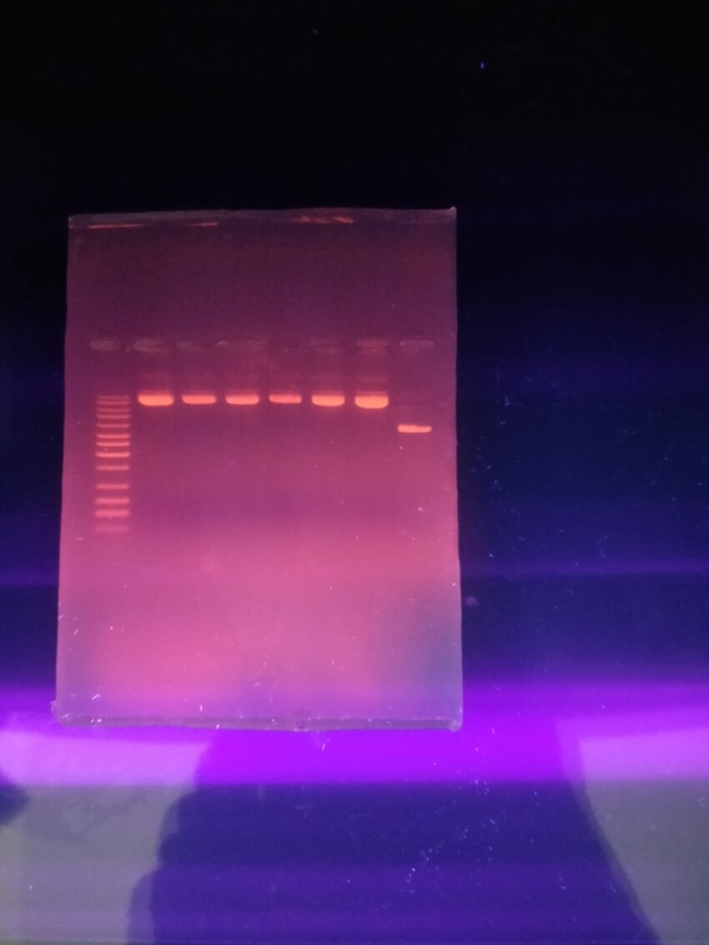
Agarose Gel Electrophoresis for DNA Separation by UG and PG Students

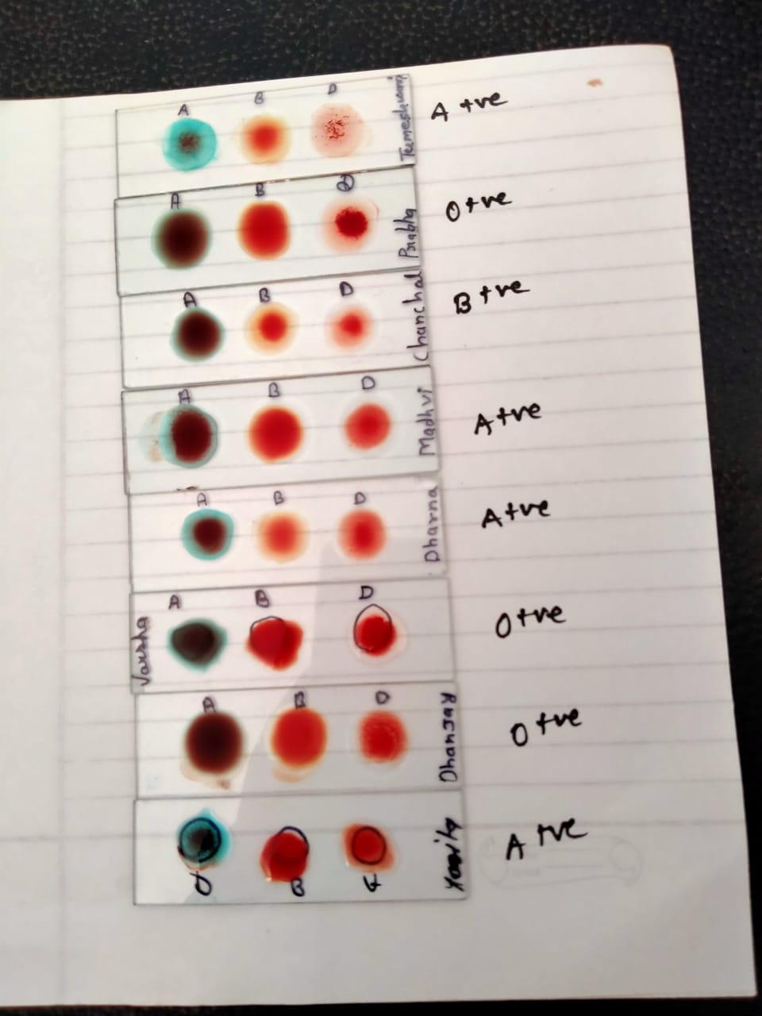
Blood Group test by UG final year students

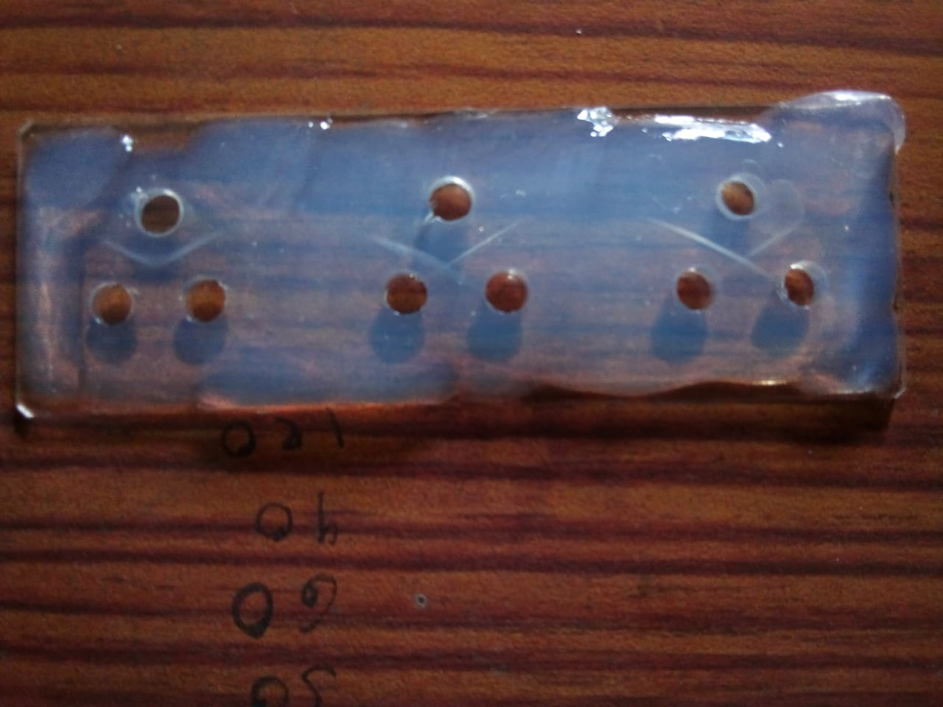
Immunological test by PG final Students

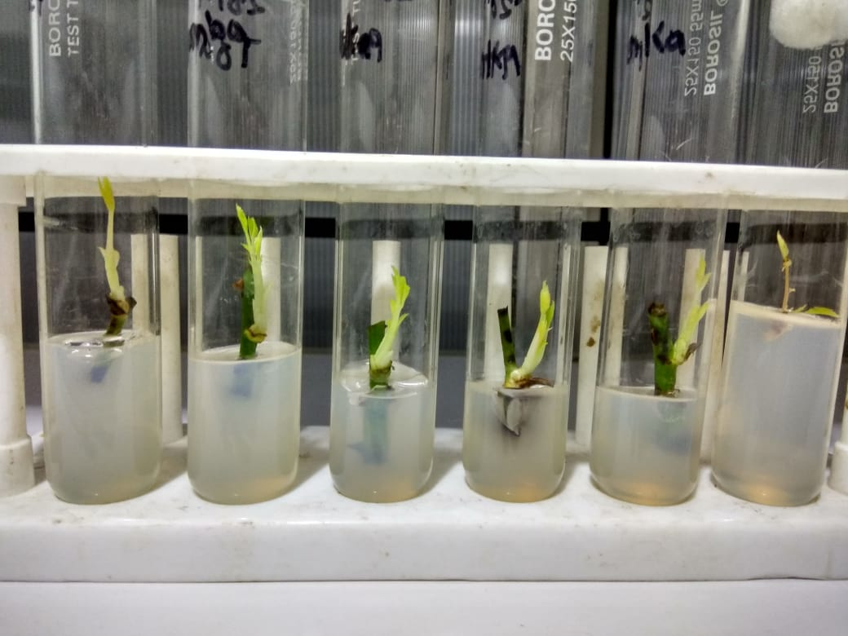
Experiments of Plant Tissue Culture

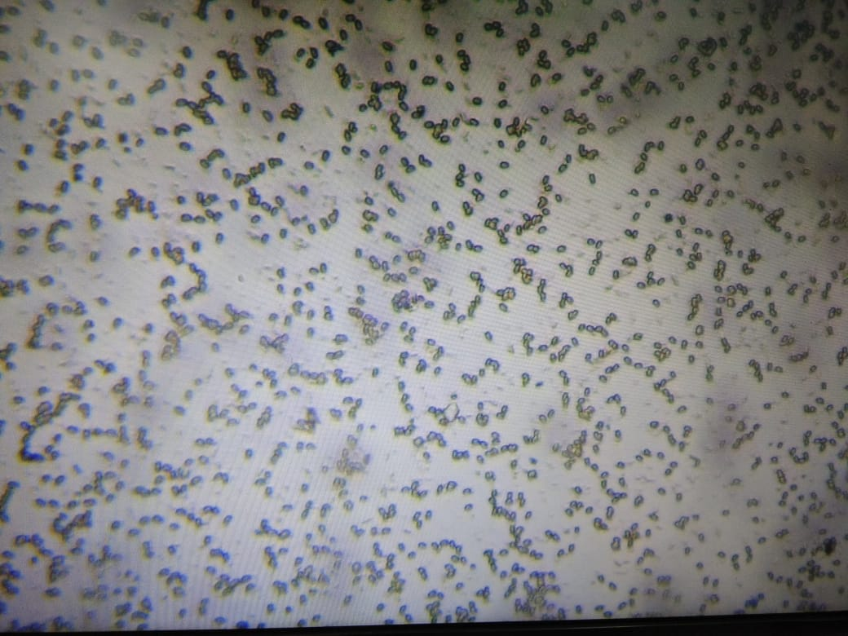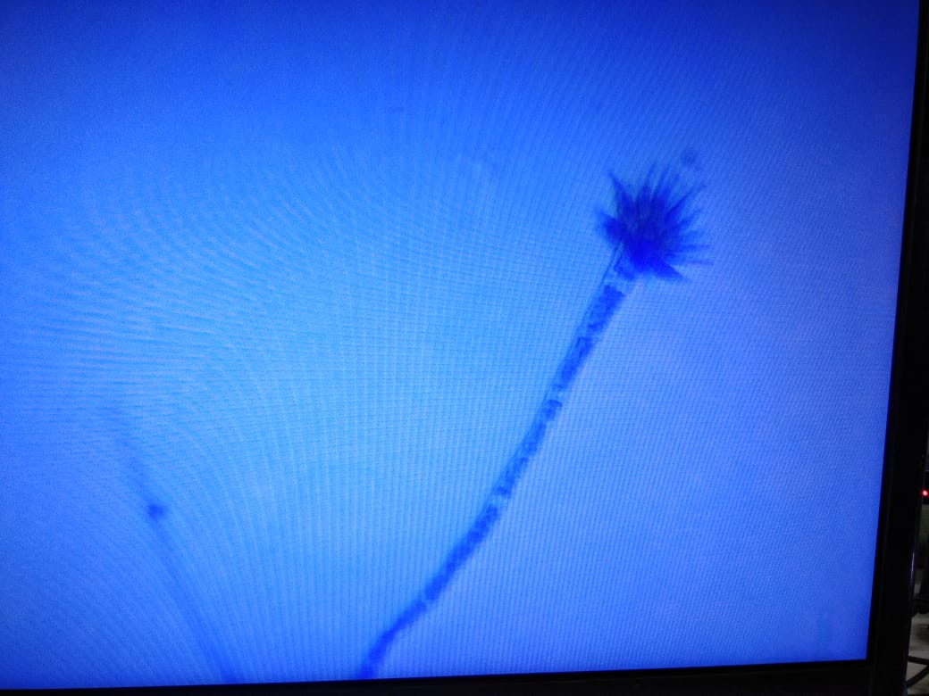
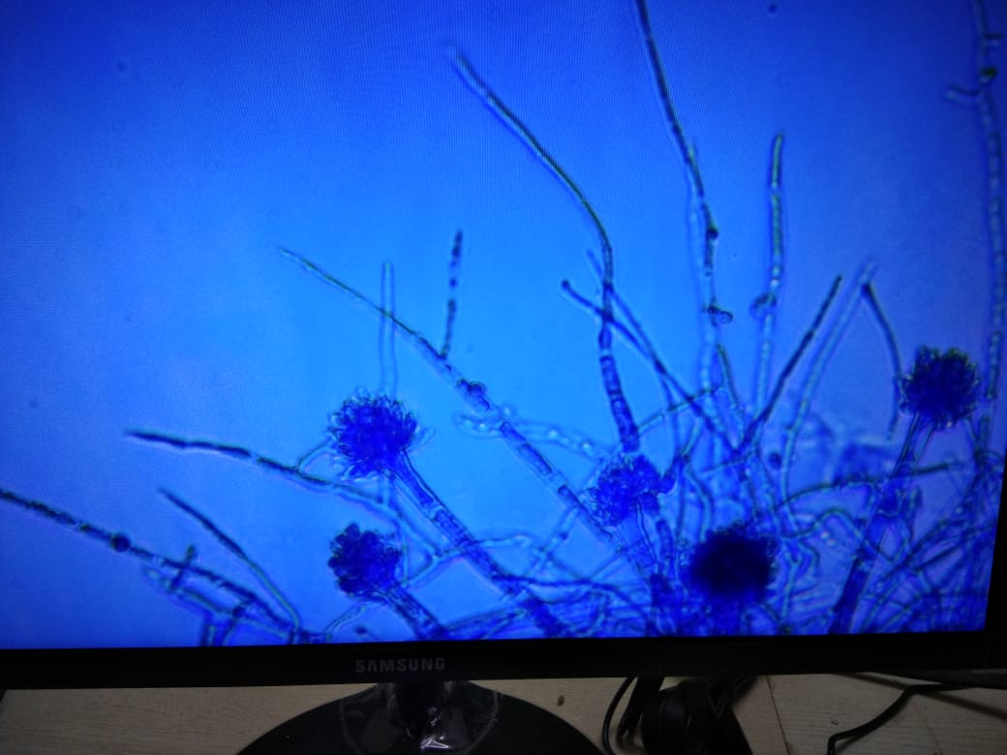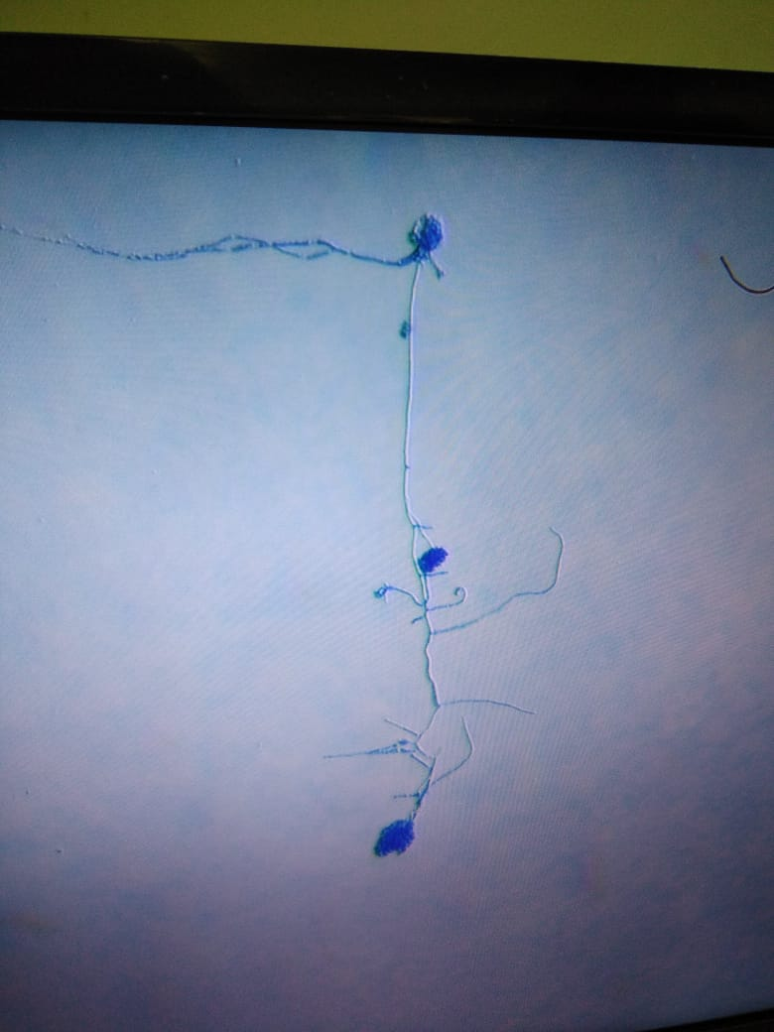

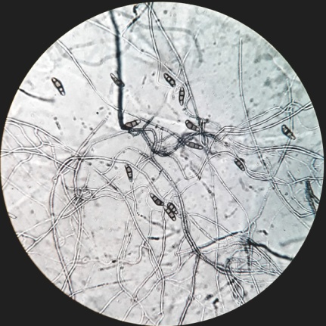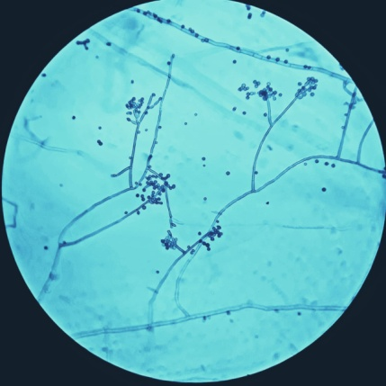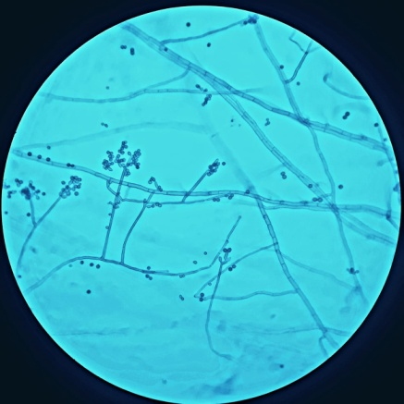
Microbiological Experiments: Isolation of Bacteria and Fungi and Observing in Microscope

Department level Workshops for Students

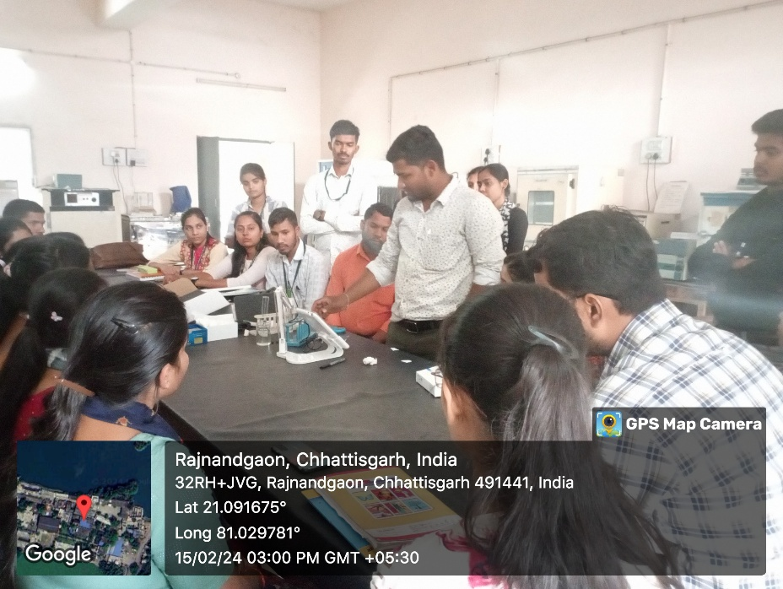
Workshop on advance pH meter

Extension Activity

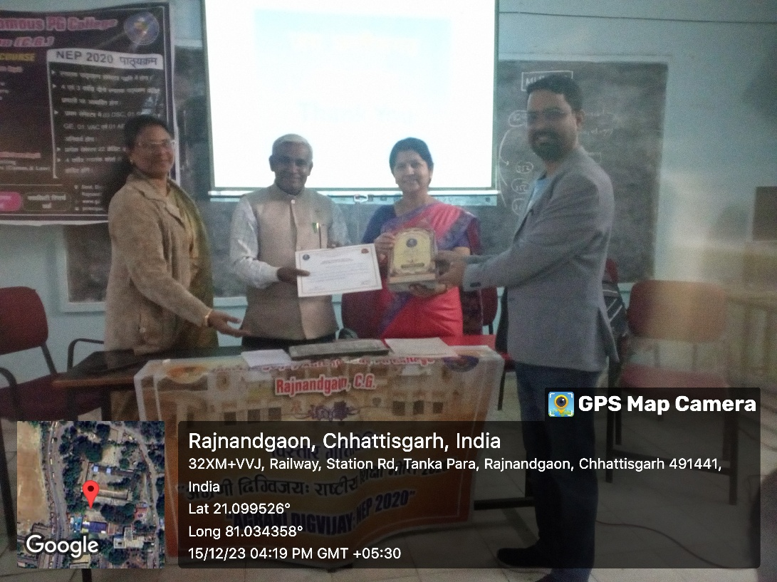
Agrani Digvijay Program in Maharani Laxmibai School

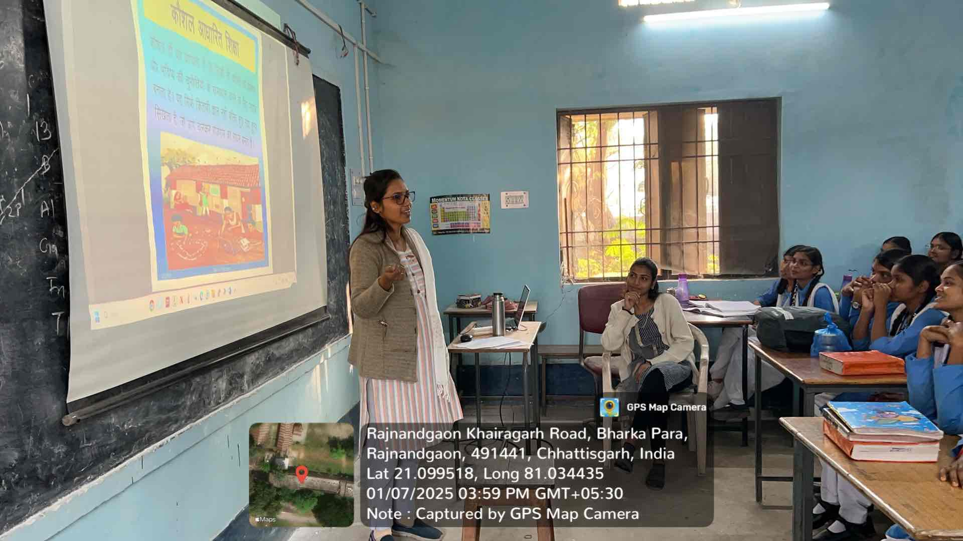
Poshak Vidyalay Program

News Reports

